**Course**: Angular L201

**Project** Name: Airlines Project

**Author**: Ujjwal Barman (M1057675)

Angular CLI version of my system:

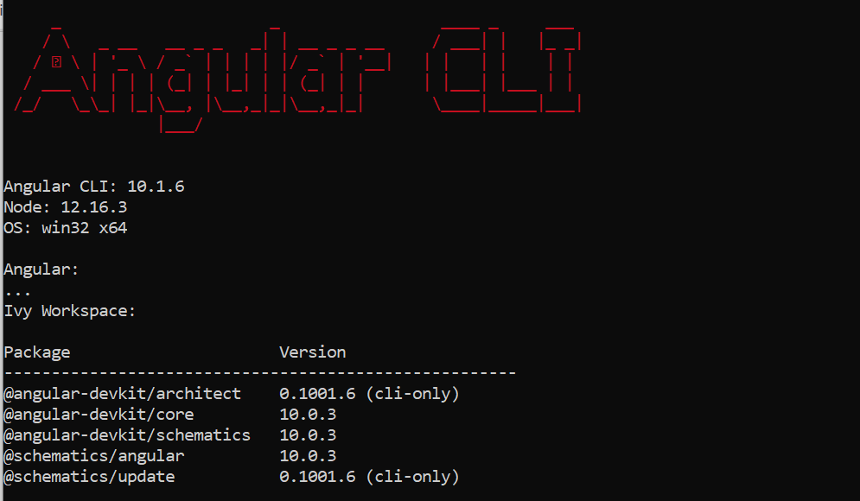

**Login Credentials:**

|  |  |
| --- | --- |
| ID | Password |
| admin | admin |
| ujjwal | ujjwal |

**Pre-requisites:**

1. Angular CLI
2. Angular 8 +
3. JSON server > npm install -g json-server

**Steps to run the application:**

1. Open project folder and start the json server with following command:

json-server –watch data/db.json

1. Run the angular application using:

ng serve

1. Login either as Admin or Staff. For admin login use the above-mentioned credentials and for staff login sign in using google account.

**Important Notes:**

1. The application must run on port 4200 for google sign in to work
2. The json server must run on port 3000

**Folders:**

1. **coverage:** Contains test coverage report.
2. **dist:** Contains application build files.

===================================================================

**Change Log: (13/11/2020)**

1. **Admin:** Only Name field is mandatory. Passport, Address and DOB can be left blank.
2. **Admin:** Implemented feature for adding wheelchair, flying with infant and special meal in Add New Passenger panel.
3. **Staff:** Added a drop-down menu for **only available seats** in update seat section while checking In.

**Previous Evaluation Chart:**

